POWER BI CHALLENGE

TASK 1 – DATASET SELECTION & IMPORT
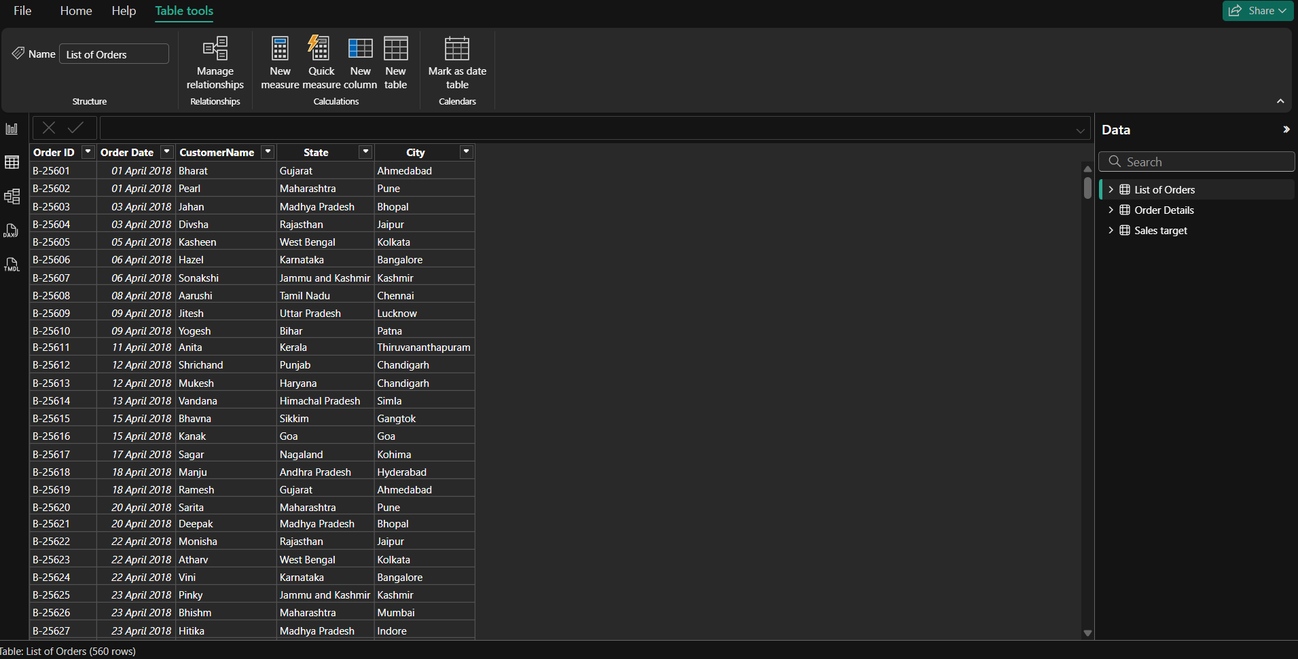
- Dataset has been imported and loaded in Power BI
- Verified that the Data is Loaded Correctly

